Tool 13: Designing pathways for accelerating learning
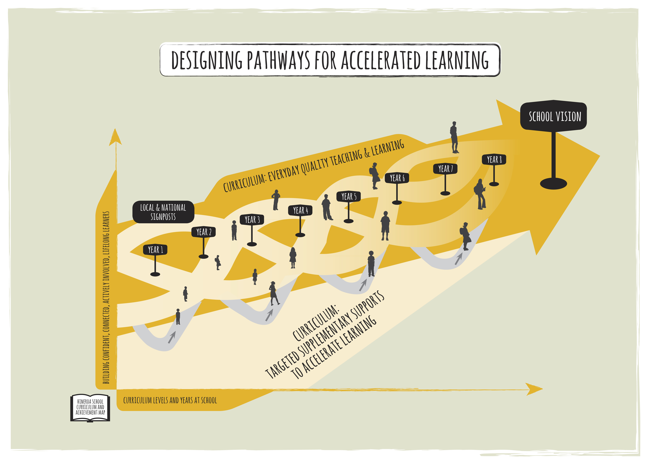
1. Purpose
A school curriculum and achievement action plan would describe what is worthwhile learning, what is achievement and how the school will respond if students are not achieving to ensure there is a period of accelerated progress.
The template (also available as an Excel file) has been developed to provide a framework for schools and regional operation teams to use curriculum-based signposts (both national and school designed signposts) to trigger supplementary supports for students.

2. Rationale
Schools need a systematic approach to the way supplementary programmes are integrated with the school curriculum. The design for such an approach is modeled off the national design and needs:
- agreed expectations for students’ literacy and mathematics outcomes;
- where there are dual settings in English medium schooling (bilingual and/or immersion classrooms), then the use of Te Marautanga o Aotearoa and Nga Whanaketanga Rumaki Māori would be mapped accordingly alongside The New Zealand Curriculum and the National Standards as the school system response to curriculum learning
- optimally effective first teaching (Tier 1);
- supplementary expert language, literacy and mathematics teaching (Tier 2) that is available in a timely and appropriate manner;
- specialist support for students who do not respond to intensive teaching (Tier 3);
- accountability to respond; and,
- leadership and management of the supplementary supports through a range of school wide monitoring.

3. Curriculum and Achievement Action Plan components
The plan would describe the following:

- The breadth and depth of the school curriculum including student outcomes that are explicitly linked to the school curriculum (described as a tangible vision or student goals).
- The expected improvements over time from one year to the next as described by particular achievement signposts e.g. the school wide plan would include the National Standards signposts and Overall Teacher Judgment information and the classroom plan would include signposts found in such documents as the Literacy Learning Progressions and The Number Framework.
- What would trigger a need to instigate a supplementary programme, e.g. end of year data, mid year data, classroom observation, for each year group and for particular groups of students
- The actual response needed to accelerate progress. This could be described by thinking about the layers of support - Tier 1 (effective classroom), Tier 2 (short and intensive school based intervention inside and/or outside of the classroom), Tier 3 (long term specialist intervention).
- Monitoring within and beyond the supplementary support.
- When and how students move from one type of support to the next e.g. a description of what happens for the students whose progress does not accelerate after an initial Tier 2 support.
Timely reviews of the school curriculum and achievement action plan would initiate discussions about the impact of classroom curriculum and supplementary curricula, and which students have access to what support so that there is ongoing improvement in the provision of all curricula.

4. Planning questions linked to each of the components
The questions in Table 1 below may help with understanding the concept of combining curriculum, achievement and supplementary supports for students and the development of a school plan. A template for a plan (using the same components as the table below) is in section 6.
Table 1: Planning questions
Curriculum and achievement action plan component | Key planning and review questions
School curriculum’s expected outcomes for students | What are the big ideas associated with learning and achievement at our school based on the school curriculum?  It could be a graduate profile that describes learning dispositions, conceptual understandings and personal values.
Student progress from one year to the next in response to the school curriculum | How do we know that students are progressing towards this profile – what are the school-based descriptors of this progress?  This could be at key points e.g. the final year of each syndicate.
National signposts associated with this progress | How do we link the national signposts (developed from the national curriculum) to our school-based curriculum?
Classroom signposts associated with this progress | What are the classroom based signposts?  These are the observable behaviours of success. They could be from documents such as the literacy learning progressions
Student learning behaviours or achievement outcomes that would trigger a Tier 2 supplementary support | What are the learning behaviours and/or outcomes that indicate we need to do something different?  How would we have noticed this?  The noticing could be from a combination of classroom observation of behaviour or a student’s piece of work, assessment tool’s data, or from an “Overall Teacher Judgment”.
Tier 2 supplementary supports available | What supplementary programmes do we provide to either prevent/ mitigate against, or are remedial for, this learning behaviour?  When are they available for students?  Some of these will be formalized whereas others will be very responsive to need.
Monitoring student progress during and after the short-term Tier 2 supplementary support was initiated | What are our triggers in our student management system that mean we always keep track of the progress of students who needed support to accelerate at some stage?
Student learning behaviours or achievement outcomes that would trigger a Tier 3 supplementary support | What learning behaviours tell us that Tier 2 support hasn’t worked?  This could be because Tier 1 and 2 were not closely aligned (see review questions)
Tier 3 supplementary supports available | What Tier 3 supplementary programmes do we provide for this learning behaviour?  This means knowing the specialist long-term support options available and being able to access the resources needed.
Monitoring student progress after the Tier 3 supplementary support was initiated | How do we ensure that what is monitored align with individual IEP?
See Self review tool for schools: focus on students achieving below curriculum expectations in Literacy (years 1-8) for a full review of school processes.

5. Implementation alerts
A curriculum and achievement action plan is not a mandatory requirement instead it is a scaffold for schools to think differently and to explicitly use aspects of the school based curriculum to trigger supplementary supports for students. It does not have any aspects of compliance. Table 2 summarises some key aspects to be aware of to ensure the development of the action plan stays focused on improved outcomes for all students, building capability and teachers and leaders working together.
Table 2: Curriculum and achievement action plan implementation alerts
 | What it is…. | What it isn’t….
School curriculum’s expected outcomes for students | The school curriculum drives the learning and achievement goals, outcomes and progress towards these.  The goals are a set of statements describing the big ideas – dispositions, conceptual understandings, and values that are important to the school community and worthwhile ensuring all students attain. | A compliance document with a range of unit plans and lessons that are not connected to a curriculum as a whole
Student learning behaviours or achievement outcomes that would trigger a Tier 2 supplementary support | Knowing how to notice, recognize and respond to any student progress that needs accelerating.  Teachers using of curriculum based tools and signposts to identify the initial need.  This could be supported through the use of specialist assessment tools to identify most suitable response.  It is about supporting these students to succeed.  It is about having supplementary supports available for all students | Teachers, teacher aides or administrators using very specific non-curriculum assessment tools e.g. BURT or very low level knowledge and skills assessment tools.  Naming and shaming students and their teachers when progress dips.  Having supplementary programmes only for the students the school expect to accelerate progress.
Supplementary supports are available | Developing a curriculum that accelerates progress and supplements effective teaching  Explicit and intensive teaching and learning programmes based on the school curriculum that involves all 4 levers for change – effective pedagogy, utilization of powerful connections, instructional leadership, inquiry and knowledge building i.e. designing all programmes to succeed.  Responsive to need  Timely  - each teacher is able to respond and develop a supplementary programme within the classroom environment  - school has system response for particular points of concern (both remedial and preventative) based on school achievement data  Cohesive use of adaptive expert teachers and specialists through the use of deliberate professional conversations about curriculum and achievement and the roles each play to support learning | A replacement for effective classroom teaching and the socio-cultural aspects of learning.  A separate entity from the school/classroom curriculum.  Reliant on expert teachers and specialists outside of the classroom
Monitoring student progress during and after the supplementary support. | Focus is on improving.  Using smart tools to monitor impact of programme in both the short and long term to make adjustments for the student/s and to the programme/s.  Monitoring includes monitoring for unintended consequences on students within or outside of the programme. | Focus on ‘proving’ that the programme made a difference.  Lack of overlap between what is assessed during and after the programme and what is assessed in the classroom.  Working in silos
Developing student agency | Students know they will be supported to achieve.  For future success they also know that they are expected to develop high-level learning strategies and self-directing strategies during the intervention. | Low level learning with a focus on knowledge.
Socio-cultural learning environment | Students able to negotiate their learning and understandings with peers along with explicit teaching with the teacher.  Teachers able to negotiate their professional learnings with peers if the focus is on classroom practice. | Only individualised programmes or personalized learning.  Focus on achievement and appraisal rather than capability building (for students, teachers and leaders)

Through the school’s strategic, regular and emerging self-review processes such as on-going monitoring and reporting of curriculum in class and in acceleration programmes, and of student progress and achievement.

